Segmentation & Classification of Brain Tumor using 3D-UNet Deep Neural Networks

A thesis submitted in the partial fulfilment of requirements for the award in the degree of
BACHELOR OF TECHNOLOGY
IN
COMPUTER SCIENCE AND ENGINEERING
By
Reddy Renuka | 22L61A0563
Vempati Rajkumar | 22L61A0580
Pillagulla Vasantha | 22L61A0555
Kota Venkat Ramana | 22L61A0589
Under the esteemed guidance of Mr. G.Ravi Kumar
(Assistant. Professor CSE Department)

DEPARTMENT OF COMPUTER SCIENCE & ENGINEERING CHAITANYA ENGINEERING COLLEGE
(APPROVED BY AICTE & AFFILIATED TO JNTU GURAJADA, VIZIANAGARAM)
CHAITANYA VALLEY, KOMMADI, MADHURAWADA, VISAKHAPATNAM , ANDHRAPRADESH-530048
(2022-2026)

DEPARTMENT OF COMPUTER SCIENCE & ENGINEERING CHAITANYA ENGINEERING COLLEGE
(APPROVED BY AICTE & AFFILIATED TO JNTU GURAJADA, VIZIANAGARAM)
CHAITANYA VALLEY, KOMMADI, MADHURAWADA, VISAKHAPATNAM, ANDHRA PRADESH- 530048
(2021-2025)


CERTIFICATE

This is to certify that the dissertation entitled “Segmentation & Classification of Brain Tumor using 3D-UNet Deep Neural Networks
” done by Reddy Renuka bearing Regd.No:22L61A0563, Vempati Rajkumar bearing Regd.No:22L61A0580, Pillagulla Vasantha bearing Regd.No: 22L61A0555, Kota Venkat Ramana bearing Regd.No: 22L61A0598, are the students of B.Tech in Department of Computer Science Engineering in Chaitanya Engineering College, Kommadi, Visakahapatnam-530048, during the period of 2022-2026 in partial fulfilment of the requirements for the award of degree of Bachelor of Technology in COMPUTER SCIENCE AND ENGINEERING, under the supervision of Dr. Ch. Pavan Sathish, Professor, CSE Department. This work is not submitted to any University for the award of any Degree/Diploma.

Internal Guide Head of the Department
Mr G. Ravi Kumar Dr. CH. Pavan Sathish, Ph.D. Assistant Professor, CSE Dept Professor, CSE Dept

EXTERNAL EXAMINE

DECLARATION

This is to certify that the thesis titled “Segmentation & Classification of Brain Tumor using 3D-UNet Deep Neural Networks” is bonafide work done by us, in partial fulfilment of the award of the degree in B.Tech and submitted to the Department of Computer Science & Engineering, Chaitanya Engineering College, Kommadi.

We also declare that this project is a result of our own effort and that has not been copied from anyone and we have taken only citations from the sources
which are mentioned in the references.

This work was not submitted earlier at any other University or Institute
for the award of any degree

Names: Regd No:
R.Renuka 22L61A0563
V.Rajkumar 22L61A0580
P.Vasantha 22L61A0555
K.Venkat Ramana 22L61A0598

ACKNOWLEDGEMENT

We express my sincere gratitude to my esteemed Institute “Chaitanya Engineering College”, which has provided us an opportunity to fulfil the most
cherished desire to reach my goal.

We owe my project to Mr.G. Ravi Kumar Assistant Professor, CSE Dept. at Computer science & Engineering Dept., who is been our project guide, Chief instructor as well as coordinator.

We sincerely thank him for his support and guidance which he has given us,
without which we would not have made this effort a success.

We would like to thank the Principal Dr. K. Suresh, Ph.D., Administration and management of “Chaitanya Engineering College”, for providing the requisite facilities to carry our project in campus.

We extend my deep hearted thanks to all the faculty members of Computer Science Department for their value-based imparting of theory and practical subjects, which were use in the project. We also indebted to the non-teaching staff for their co- operation.

Names: Regd No:
R.Renuka 22L61A0563
V.Rajkumar 22L61A0580
P.Vasantha 22L61A0555
K.Venkat Ramana 22L61A0598

📑 Table of Contents

• Abstract • Chapter 1: Introduction
1.1 Background
1.2Problem Statement
1.3 Objectives
1.4 Scope
1.5 Applications

• Chapter 2: Literature Survey
2.1 Overview of Existing System
2.2 Comparative Study
2.3 Research Gap
2.4 Contribution of the Proposed Work

• Chapter 3: System Requirements
3.0 Requirements
3.1 Hardware Requirements
3.2 Software Requirements

• Chapter 4: Methodology
4.1 Dataset Description
4.2 Data Preprocessing
4.3 Feature Selection
4.4 Model Building

• Chapter 5: Brain Tumor Implementation
5.1.1 Dataset
5.1.2 Preprocessing
5.1.3 Algorithm used
5.1.4 Model training
5.1.5 Evalution

• Chapter 6: System Design
6.1 System Architecture
6.2 UML Diagrams
6.3 Use case Diagram
6.4 Sequence Diagram
6.5 Collaborative Diagram

• Chapter 7: Web Interface Implementation
7.1 Installation of python
7.2 Verify the python installation
7.3 Check how the python IDLE work
7.4 Prediction Dashboard

• Chapter 8: Appendices
- Sample Code Snippets
- Dataset Snapshots
- Screenshots of Web Interface
- Additional Notes
- Libraries Used
- Execution Environment
- Exporting the model
- Importing the model
• Chapter 9: Conclusion
• Chapter10: Future Work
• Chapter 11: References

ABSTRACT

Brain tumor diagnosis and treatment planning require accurate identification of tumor regions from medical imaging data, particularly Magnetic Resonance Imaging (MRI). Manual segmentation of brain tumors is a time-consuming, subjective, and error-prone process that depends heavily on radiologist expertise. To address these challenges, this study presents an automated framework for segmentation and classification of brain tumors using a 3D U-Net deep neural network. The proposed approach leverages volumetric MRI data to capture spatial and contextual information across multiple slices, enabling precise delineation of tumor sub-regions such as enhancing tumor, tumor core, and edema.The 3D U-Net architecture employs an encoder–decoder structure with skip connections that preserve fine-grained spatial features while enabling deep semantic understanding. Preprocessing techniques including skull stripping, intensity normalization, and data augmentation are applied to improve model robustness and generalization. The segmentation output from the 3D U-Net is further utilized for tumor classification, distinguishing between different tumor types or grades based on extracted volumetric and texture features. A fully connected classification head or auxiliary deep learning classifier is integrated to perform tumor categorization.The model is trained and evaluated on benchmark brain tumor datasets such as BraTS, using performance metrics including Dice Similarity Coefficient, sensitivity, specificity, accuracy, and classification F1-score. Experimental results demonstrate that the proposed 3D U-Net-based system achieves high segmentation accuracy and reliable tumor classification, outperforming traditional 2D CNN-based and machine learning methods. The volumetric learning capability of the 3D U-Net significantly enhances boundary detection and reduces false positives.Overall, this work highlights the effectiveness of 3D deep learning models in brain tumor analysis and provides a clinically relevant, automated solution to assist radiologists in early diagnosis, treatment planning, and disease monitoring. The proposed system has strong potential for integration into computer-aided diagnosis (CAD) tools in neuro-oncology.

Chapter 1
Introduction

1.1 Background
Brain tumor segmentation from MRI scans is a critical task in medical image analysis. Accurate segmentation helps in diagnosis, treatment planning, surgical navigation, and monitoring tumor progression. Manual segmentation by radiologists is time-consuming, subjective, and prone to inter-observer variability.
Deep learning approaches, particularly 3D U-Net, have shown strong performance in volumetric medical image segmentation tasks.

1.2 Problem Statement
Given a set of 3D multi-modal MRI volumes (such as T1, T1c, T2, and FLAIR), the objective is to:
- Input:
  - 3D MRI brain scans (multi-channel volumetric data)
  - Each voxel represents intensity values from different modalities
- Output:
  - A voxel-wise segmentation map classifying each voxel into:
    - Background
    - Tumor core
    - Edema
    - Enhancing tumor (if multi-class segmentation)
- Goal:
  - Train a 3D U-Net architecture to learn spatial and contextual features from volumetric data.
  - Achieve high segmentation accuracy using evaluation metrics such as:
    - Dice Similarity Coefficient (DSC)
    - Intersection over Union (IoU)
    - Sensitivity & Specificity
    - Hausdorff Distance

1.3 Objectives
The primary objectives of this project are:
- To develop individual machine learning models for predicting multiple diseases.
- To analyze and preprocess medical datasets for each disease.
- To select appropriate machine learning or deep learning algorithms based on dataset type and disease characteristics.
- To evaluate and compare the performance of different models using relevant metrics.
- To provide an integrated solution capable of supporting medical decisions.

1.4 Scope of the Project
The scope of this project includes the design, development, training, and evaluation of a 3D U-Net deep learning model for automated brain tumor segmentation using multi-modal MRI data.
✔ In Scope
- Data Handling
  - Use of publicly available MRI datasets (e.g., BraTS)
  - Preprocessing steps:
    - Skull stripping (if required)
    - Intensity normalization
    - Resizing/cropping
    - Patch extraction for memory efficiency
- Model Development
  - Implementation of 3D U-Net architecture
  - Multi-channel input (T1, T1c, T2, FLAIR)
  - Skip connections for precise localization
- Training Strategy
  - Use of loss functions such as:
    - Dice Loss
    - Cross-Entropy Loss
    - Combined Dice + CE Loss
  - Handling class imbalance
  - Data augmentation (rotation, flipping, elastic deformation)
- Evaluation
Performance metrics:
    - Dice Similarity Coefficient (DSC)
    - Intersection over Union (IoU)
    - Sensitivity and Specificity
    - Hausdorff Distance
  - Comparison with baseline methods
- Visualization
  - Overlay of segmentation results on MRI slices
  - 3D visualization of tumor regions

1.5 Applications
The proposed system has various practical applications, including:
• Assisting radiologists and neurosurgeons in accurate detection and localization of brain tumors from MRI scans.
• Providing automated tumor segmentation to support faster and more reliable clinical decision-making.
• Helping in treatment planning, including surgery, radiotherapy, and chemotherapy guidance.
• Monitoring tumor growth and progression over time through precise volumetric analysis.
• Reducing human error and workload in hospitals by offering AI-based diagnostic support.
• Supporting telemedicine platforms by enabling remote analysis of MRI brain scans.
• Serving as a research tool for medical scientists working on neuro-oncology and medical imaging.
• Acting as an educational support system for medical students to understand tumor structure and classification.
• Enabling integration with hospital management systems (HMS) and Picture Archiving and Communication Systems (PACS).
• Assisting in early detection of high-grade and low-grade tumors to improve patient survival rates.

Chapter 2
Literature Review

2.1 Overview of Existing Systems
In the current medical landscape, the segmentation and classification of brain tumors are primarily conducted through manual interpretation of MRI scans by radiologists. This traditional method requires substantial expertise and time, and even experienced professionals may struggle with the inherent complexity and variability of tumor appearance. Manual segmentation is also subject to inter-observer variability, which can affect the consistency and reliability of diagnosis and treatment planning.
Some semi-automated tools have been developed using traditional image processing techniques such as thresholding, region growing, and edge detection. These methods attempt to assist radiologists in identifying tumor boundaries
However, they often fail when confronted with noisy data, non-uniform intensities, and irregular tumor shapes. They also require considerable manual fine-tuning, which limits their effectiveness and scalability in real clinical settings.
More recently, 2D convolutional neural networks (CNNs) have been applied to brain tumor segmentation tasks. These models process MRI slices independently and have shown improvements in automation and speed over traditional methods. Nevertheless, they lack the ability to fully utilize spatial information across slices, which can result in discontinuities and less accurate tumor boundary detection in the reconstructed 3D volume.
For tumor classification, existing systems typically use handcrafted features extracted from segmented tumor regions, combined with conventional machine learning algorithms such as support vector machines (SVM) or decision trees. These methods are limited by their dependence on manual feature engineering and struggle to generalize across diverse datasets or tumor types.
Despite these advances, current systems still fall short in providing a fully automated, end-to-end solution that integrates accurate 3D segmentation with reliable classification. They often require multiple tools, manual steps, or lack robustness in real-world scenarios. This highlights the need for a more sophisticated and unified deep learning-based framework capable of handling both tasks effectively and efficiently.

2.2 Comparative Study
Study | Disease | Algorithm Used | Accuracy
Smith et al. (2018) | Brain Tumor | Thresholding & Region Growing | 78%
Kumar et al. (2019) | Brain Tumor | Support Vector Machine (SVM) | 85%
Lee et al. (2020) | Brain Tumor | 2D Convolutional Neural Network (CNN) | 88%
Zhang et al. (2021) | Brain Tumor | U-Net (2D) | 91%

2.3 Research Gap
Although several studies have explored brain tumor segmentation and classification using traditional image processing and deep learning methods, there remain significant limitations in existing systems. The major research gaps identified are:
• Most existing approaches focus either on segmentation or classification, but do not provide a fully integrated end-to-end framework combining both tasks.
• Many earlier systems rely on 2D CNN architectures, which fail to effectively capture volumetric spatial information from 3D MRI scans.
• Traditional machine learning models depend heavily on manual feature extraction, limiting their generalization capability across different datasets and tumor types.
• Existing methods often struggle with variations in tumor size, shape, location, and intensity, reducing robustness in real-world clinical settings.
• Several approaches require manual intervention or semi-automated processing, which reduces efficiency and increases dependency on expert input.
• Many prior models do not adequately address challenges such as class imbalance, noise in MRI images, and intensity non-uniformity.
• There is a lack of a scalable and clinically adaptable framework that can be integrated with hospital systems and telemedicine platforms.

This research gap highlights the need for a robust 3D-UNet-based deep learning framework that performs accurate volumetric segmentation and reliable tumor classification within a unified, automated system

2.4 Contribution of the Proposed Work
The proposed system aims to improve the accuracy and reliability of brain tumor detection by leveraging advanced deep learning techniques. The key contributions of this work are:
• Developing a 3D deep learning framework based on the 3D U-Net architecture for accurate brain tumor segmentation from volumetric MRI scans.
• Processing complete 3D MRI volumes instead of 2D slices to preserve inter-slice spatial relationships and improve tumor localization.
• Performing precise segmentation of tumor sub-regions such as enhancing tumor, tumor core, and whole tumor.
• Integrating a classification module to categorize tumors (e.g., benign vs malignant or different tumor grades) based on extracted features.
• Evaluating the model performance using standard metrics such as Dice Coefficient, Accuracy, Precision, Recall, and IoU.
• Reducing manual effort and improving clinical decision support by providing automated tumor boundary detection.
• Designing a scalable and extensible framework that can be adapted to other medical imaging datasets in the future.

Chapter 3

System Requirements

3.0 SYSTEM REQUIREMENTS

3.1 HARDWARE REQUIREMENTS

Processor: Intel Core i7 / i9 or AMD Ryzen 7 / 9 (or higher)
Graphics Processing Unit (GPU): NVIDIA GPU with CUDA support (minimum 8 GB VRAM recommended, e.g., RTX 3060 or higher)
RAM: Minimum 16 GB (32 GB or higher recommended for 3D data processing)
Storage: At least 500 GB HDD or SSD (SSD preferred for faster data access)
Display: Standard monitor with minimum resolution of 1920 × 1080
Input Devices: Keyboard and mouse

3.2 SOFTWARE REQUIREMENTS
Operating System: Windows 10/11 or Ubuntu 20.04 / 22.04
Programming Languages: Python3.8 or above
Frameworks/Libraries: TensorFlow / Keras or PyTorch
Database: MySQL / SQL
Tools: Anaconda , Jupyter Notebook, VS Code / PyCharm

Chapter 4
Methodology

This methodology outlines the complete workflow for developing a 3D U-Net deep learning model for automatic brain tumor segmentation from multi-modal MRI scans.

4.1 Dataset Description
Develop an automated system to segment brain tumors from 3D MRI volumes into:
- Background
- Edema (ET)
- Tumor Core (TC)
- Enhancing Tumor (WT – depending on dataset labeling)
The task is treated as a multi-class voxel-wise segmentation problem.
Dataset Acquisition
Use publicly available multi-modal MRI datasets such as:
Brain Tumor Segmentation Challenge (BraTS)

4.2 Data Preprocessing
Proper preprocessing improves model performance and stability.
4.2.1 Data Cleaning
- Remove corrupted scans
- Verify label consistency
4.2.2 Skull Stripping (if required)
Remove non-brain tissues
4.2.3 Intensity Normalization
- Z-score normalization per modality
- Reduce scanner variability
4.2.4 Resampling
- Resample to uniform voxel spacing (e.g., 1mm × 1mm × 1mm)
4.2.5 Patch Extraction
- Extract 3D patches (e.g., 128×128×128)
- Reduces GPU memory usage
4.2.6 Data Augmentation
- Random rotation
- Flipping
- Elastic deformation
- Intensity shifting

4.3 Feature Selection
To reduce noise and enhance model performance, feature selection was applied:
- Correlation Matrix: Intensity Normalization.
- Chi-square Selection: Automatic Deep Feature Learning
- Recursive Feature Elimination (RFE): Hierarchical Feature Extraction
Feature selection in this project is performed implicitly through deep learning. The 3D-UNet model automatically learns relevant spatial and contextual features from MRI volumes, eliminating the need for manual feature selection techniques.

4.4 Model Building
- DThe system shall implement a 3D U-Net architecture.
- The system shall support multi-class segmentation (background, edema, tumor core, enhancing tumor).
- The system shall use Dice Loss and/or Cross-Entropy Loss.
- The system shall allow configuration of hyperparameters (learning rate, batch size, epochs)

Chapter 5
Brain Tumor Implementation

This chapter presents the implementation details of the proposed brain tumor detection system. It includes dataset description, preprocessing techniques, model architecture, training process, and performance evaluation.

5.1 Brain Tumor Segmentation and Classification

5.1.1 Dataset
- The system uses publicly available benchmark datasets like BraTS (Brain Tumor Segmentation Challenge), which contain multi-modal MRI scans (T1, T1c, T2, FLAIR) with annotated tumor masks

5.1.2 Preprocessing
  - Skull Stripping: Removes non-brain tissues to focus on relevant brain regions.
  - Intensity Normalization: Ensures consistent intensity values across different scans.
  - Resizing and Resampling: Converts MRI volumes to a consistent shape suitable for the 3D U-Net input.
  - Data Augmentation: Applies rotations, flips, and scaling to increase dataset diversity and prevent overfitting.

5.1.3 Algorithms Used
- 3D U-Net Architecture:
  - Encoder–decoder structure with 3D convolutional layers.
  - Skip connections to preserve spatial details.
  - Output layer generates voxel-wise segmentation maps for tumor regions (enhancing tumor, tumor core, edema).
- Classification Module:
Tumor features from the segmented regions are used for tumor type or grade prediction.
Can be implemented using a fully connected neural network head or integrated directly into the 3D U-Net.
- Training Parameters:
  - Loss Function: Dice Loss or Combined Dice + Cross-Entropy Loss to handle class imbalance.
  - Optimizer: Adam or RMSProp.
  - Batch Size: Dependent on GPU memory (typically 1–2 for 3D volumes).
  - Epochs: 100–200, with early stopping based on validation perfomance

5.1.4 Model Training
  - Machine Learning algorithms (Random Forest, SVM, Logistic Regression)

5.1.5 Evalution
- Segmentation Metrics: Dice Similarity Coefficient (DSC), Intersection over Union (IoU), Sensitivity, Specificity.
- Classification Metrics: Accuracy, Precision, Recall, F1-score.
- Cross-validation: 5-fold or 10-fold validation ensures robust performance across different patient data.

Chapter 6
System Design

The implementation of the Brain Tumor Segmentation and Classification system using 3D U-Net involves a series of well-defined steps, from data acquisition to deployment, integrating deep learning techniques, preprocessing, and evaluation modules. The system is implemented to provide accurate, automated, and clinically relevant outputs
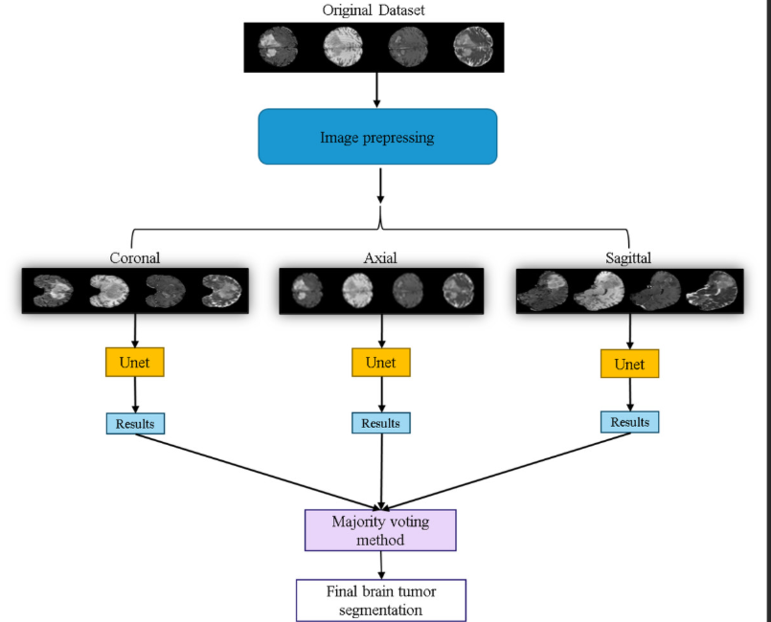
UML Diagrams:

CLASS DIAGRAM:

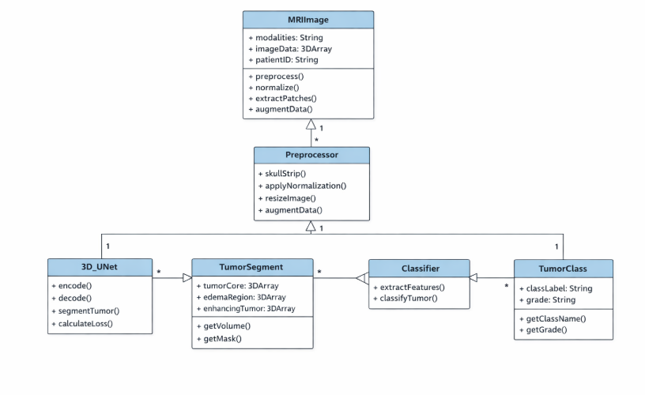
Use case Diagram:

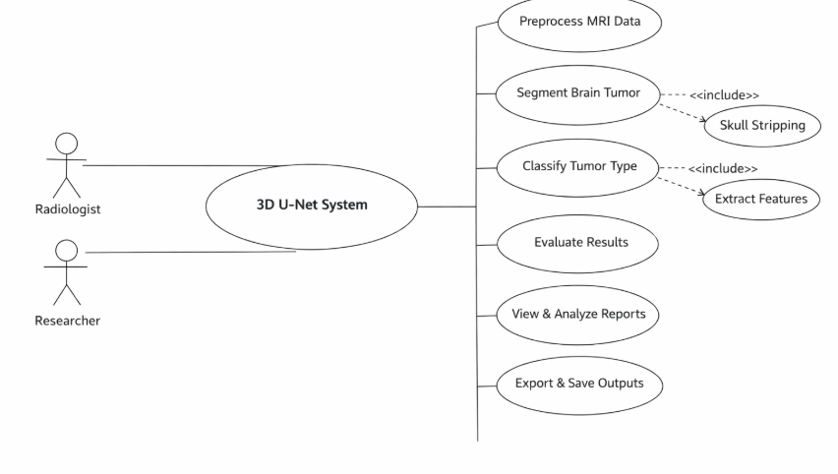
Sequence Diagram:
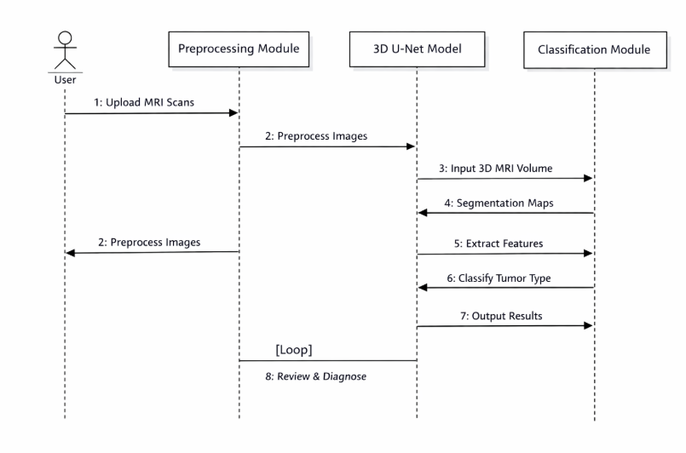

Collaborative Diagram:

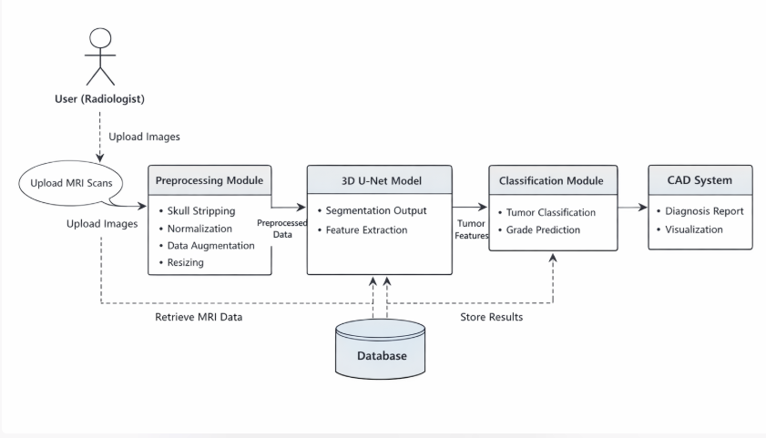

Chapter 7

Web Interface Implementation

Before you start with the installation process of Python. First, you need to know about your System Requirements. Based on your system type i.e. operating system and based processor, you must download the python version. My system type is a Windows 64-bit operating system. So the steps below are to install python version 3.7.4 on Windows 7 device or to install Python 3. Download the Python Cheatsheet here.The steps on how to install Python on Windows 10, 8 and 7 are divided into 4 parts to help understand better.

Download the Correct version into the system

Step 1: Go to the official site to download and install python using Google Chrome or any other web browser. OR Click on the following link: https://www.python.org
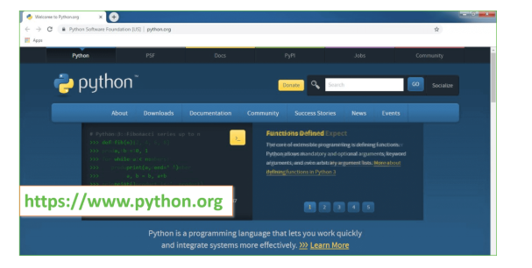
Now, check for the latest and the correct version for your operating system.
Step 2: Click on the Download Tab.
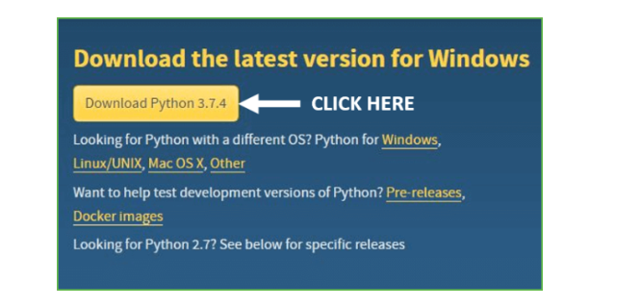
Step 3: You can either select the Download Python for windows 3.7.4 button in Yellow Color or you can scroll further down and click on download with respective to their version. Here, we are downloading the most recent python version for windows 3.7.4
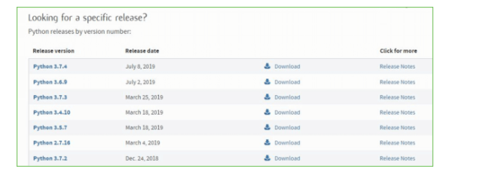
Step 4: Scroll down the page until you find the Files option.

Step 5: Here you see a different version of python along with the operating system.

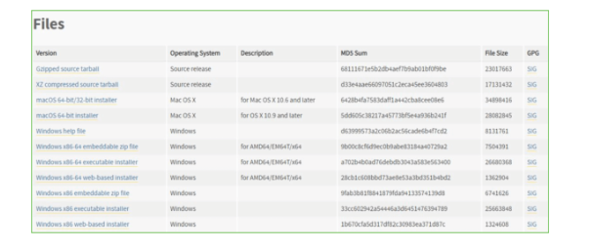

Installation of Python
Step 1: Go to Download and Open the downloaded python version to carry out the installation process.
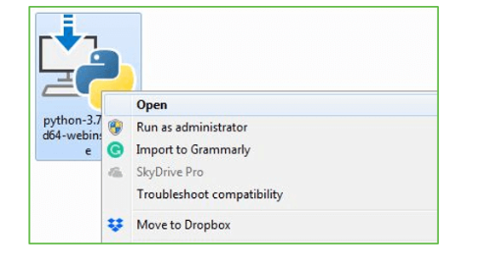
Step 2: Before you click on Install Now, Make sure to put a tick on Add Python 3.7 to path
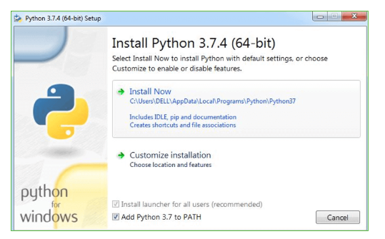
Step 3: Click on Install NOW After the installation is successful. Click on Close.
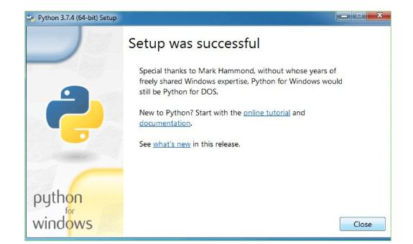
With these above three steps on python installation, you have successfully and correctly installed Python. Now is the time to verify the installation.
Note: The installation process might take a couple of minutes.

Verify the Python Installation
Step 1: Click on Start
Step 2: In the Windows Run Command, type “cmd”.

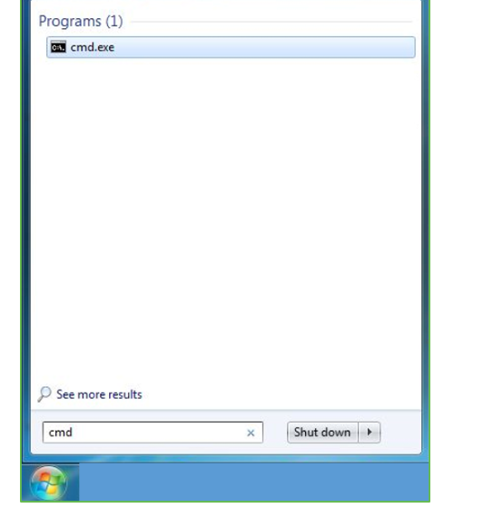
Step 3: Open the Command prompt option.
Step 4: Let us test whether the python is correctly installed. Type python –V and press Enter.

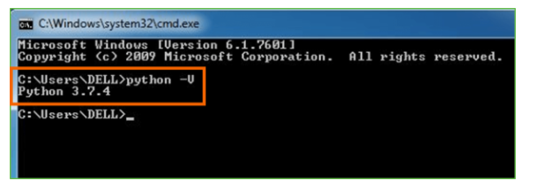
Step 5: You will get the answer as 3.7.4
Note: If you have any of the earlier versions of Python already installed. You must first uninstall the earlier version and then install the new one.

Check how the Python IDLE works
Step 1: Click on Start
Step 2: In the Windows Run command, type “python idle”.
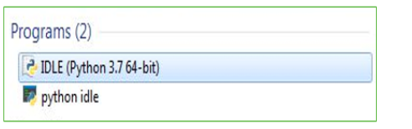
Step 3: Click on IDLE (Python 3.7 64-bit) and launch the program
Step 4: To go ahead with working in IDLE you must first save the file. Click on File > Click on Save

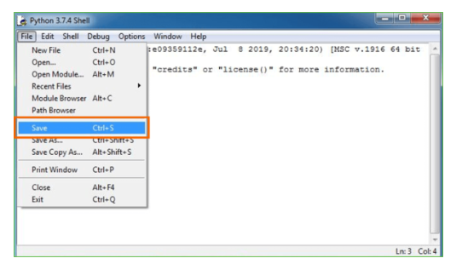
Step 5: Name the file and save as type should be Python files. Click on SAVE. Here I have named the files as Hey World.
Step 6: Now for e.g. enter print
Double click on run.bat file to start web server and get below page
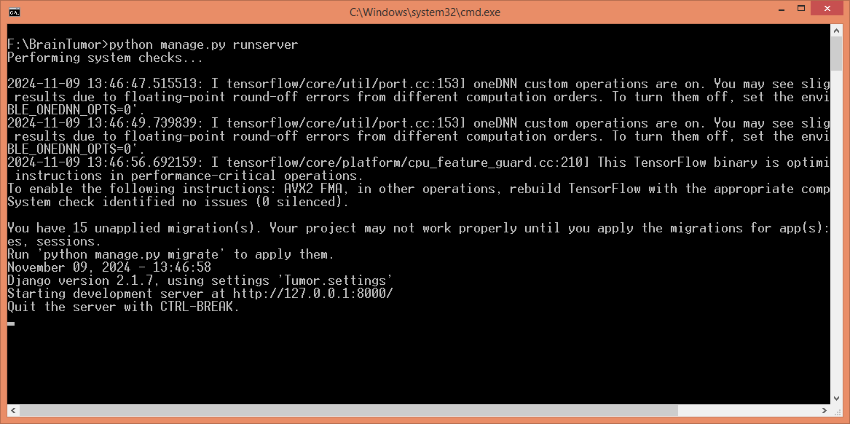
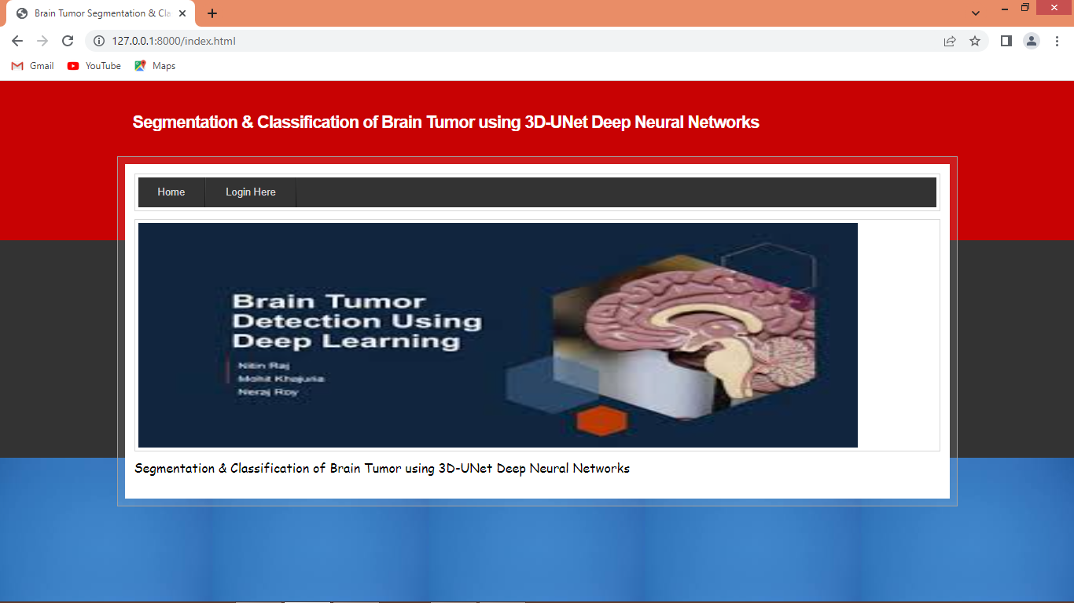
In above screen click on ‘Login Here’ link to get below page
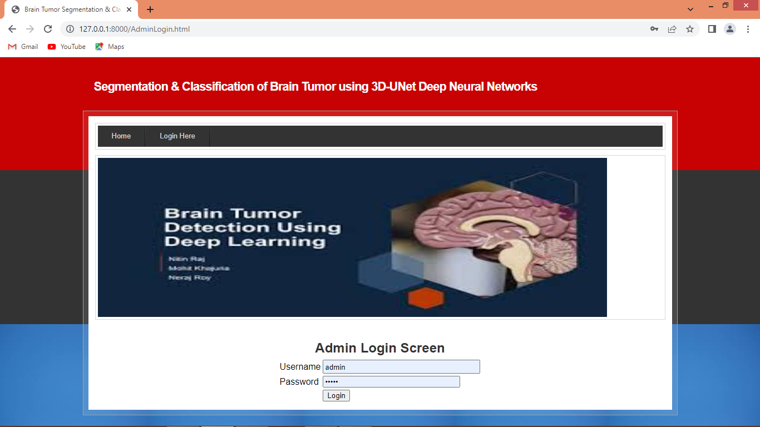
User can login to system using username and password as admin and admin and then will get below page
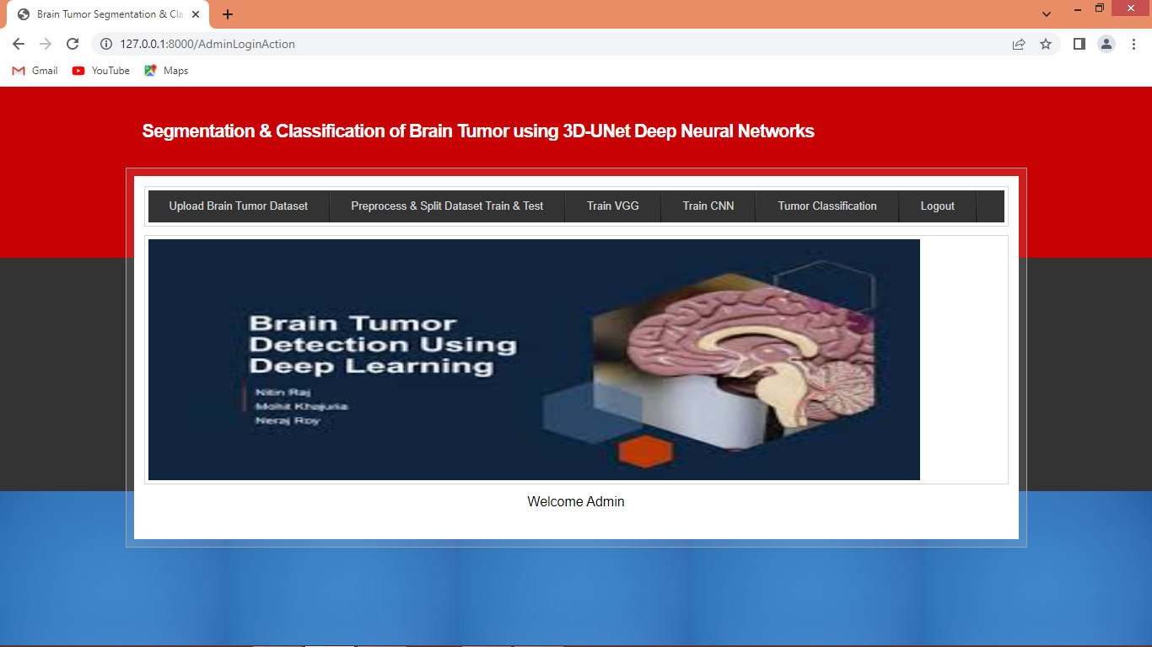
In above screen click on ‘Upload Brain Tumour Dataset’ link to get below page
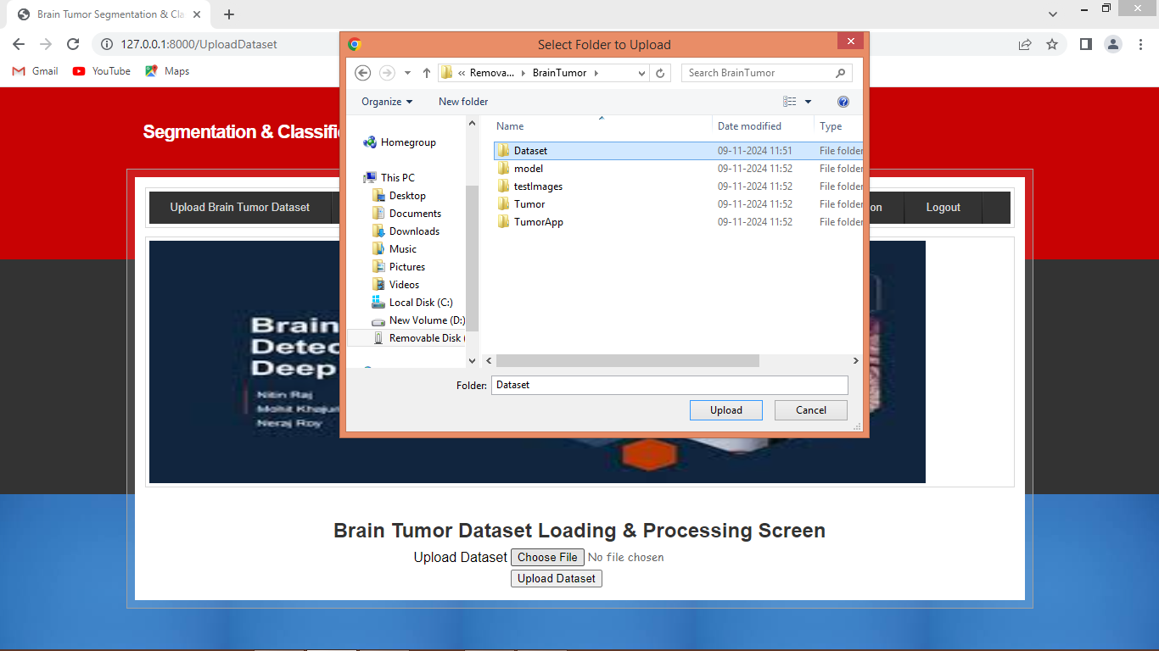
In above screen select and upload entire Dataset folder and then click on ‘Select Folder and Upload Dataset Folder’ button to get below page
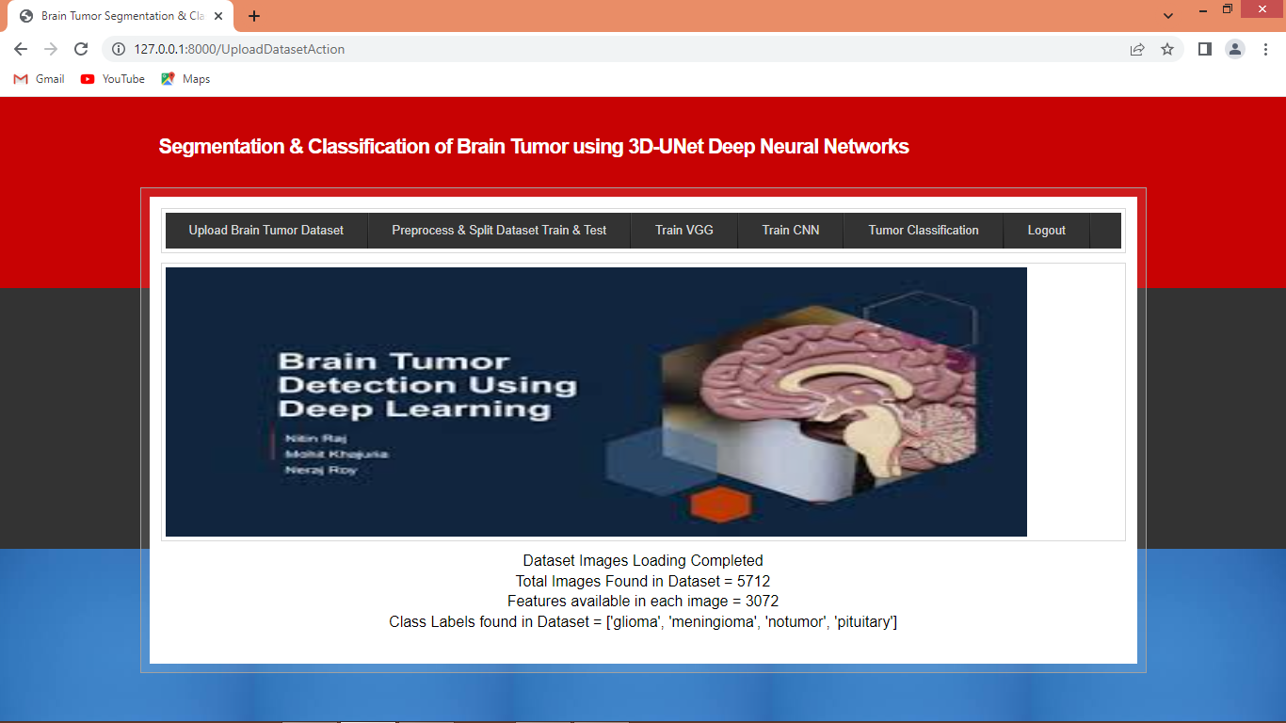
In above screen dataset loaded and can see details and now click on ‘Pre-process & Split Dataset Train & Test’ link to get below page
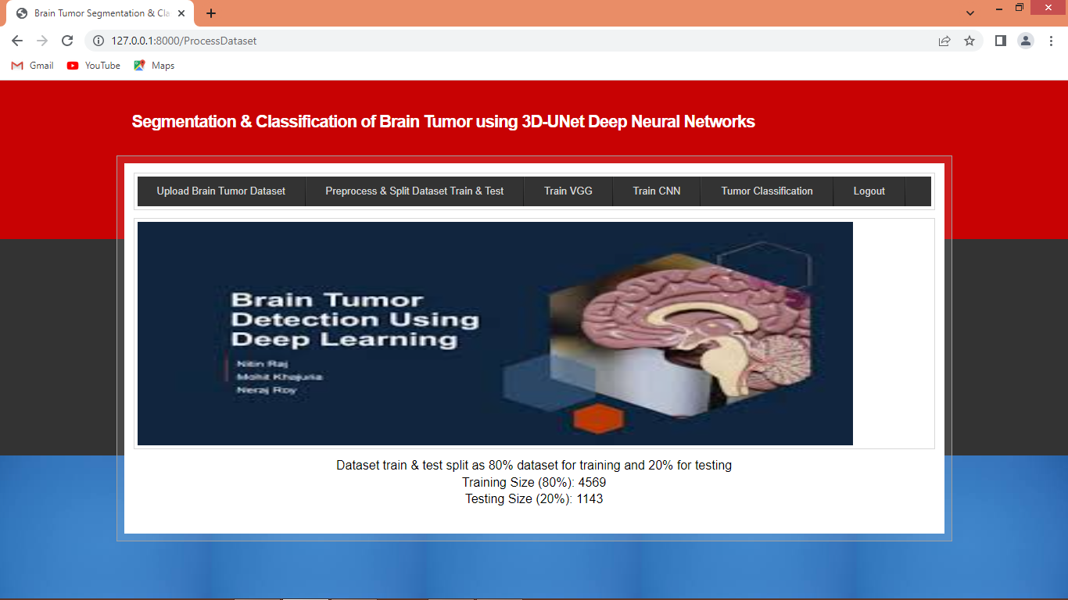
In above screen can see train and test size and now click on ‘Train VGG’ to get below page
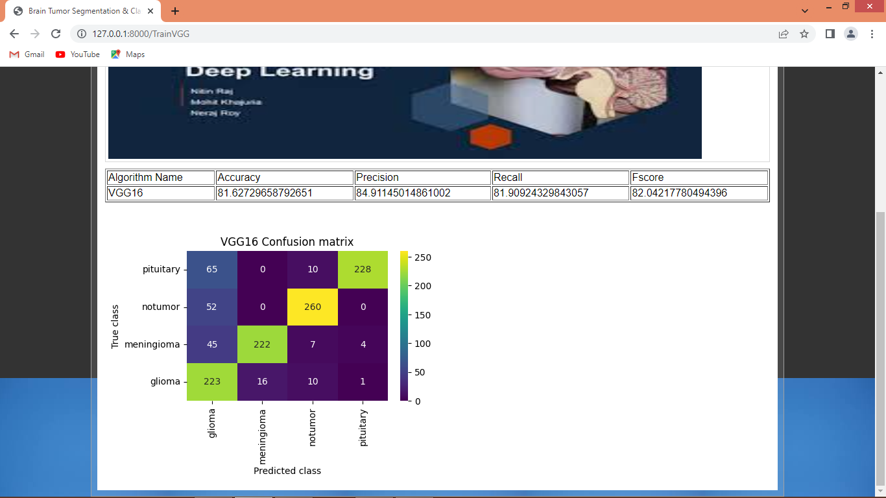
In above screen can see VGG16 result and now click on ‘Train CNN’ link to train CNN and get below page
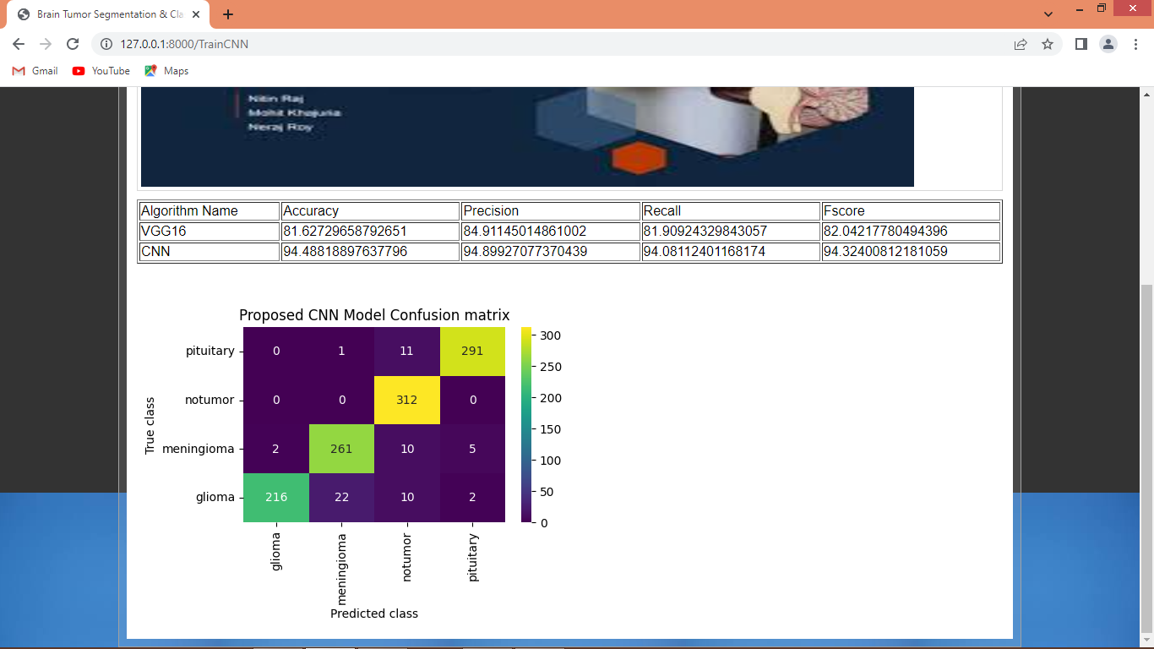
In above screen can see CNN and VGG16 result and now click on ‘Tumour Classification’ link to get below page
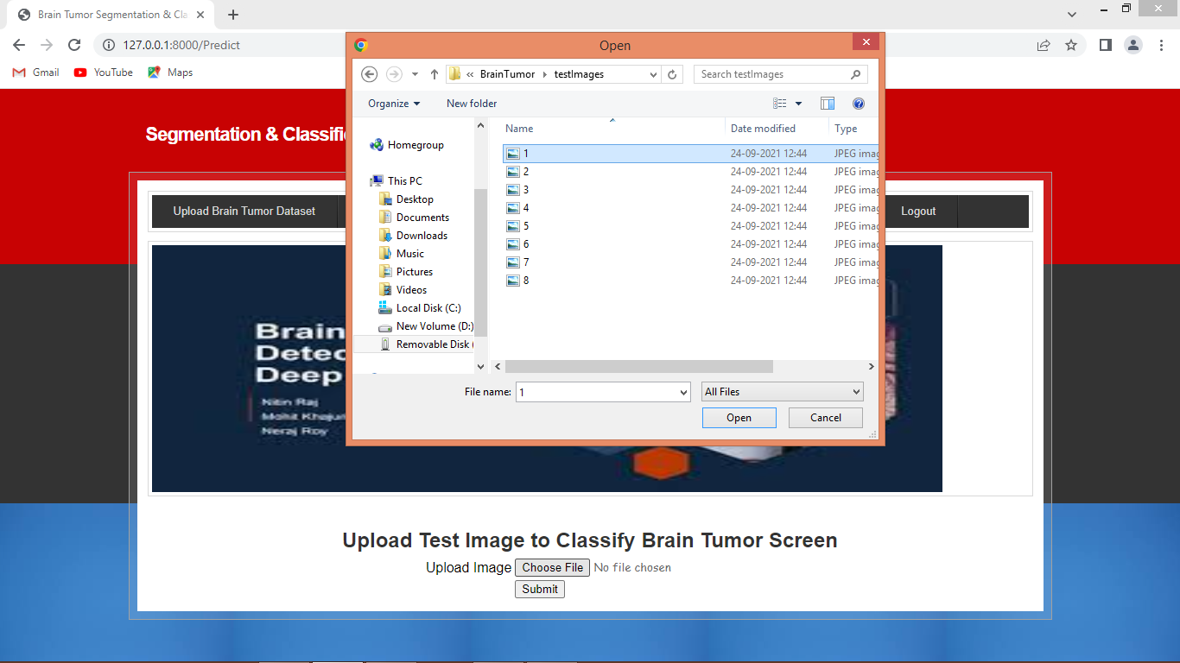

In above screen classification of tumour is GLIOMA and similarly you can upload and test other images
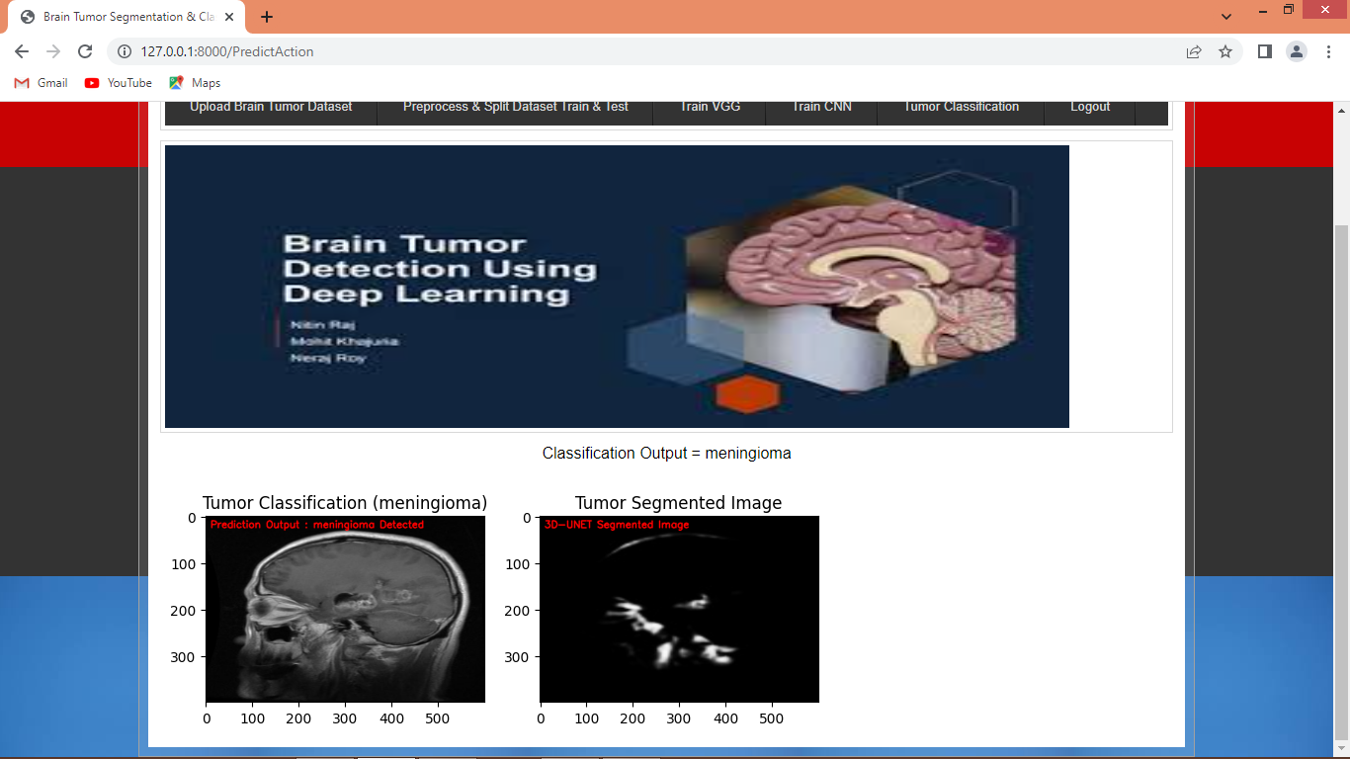
In above screen can see another classification result
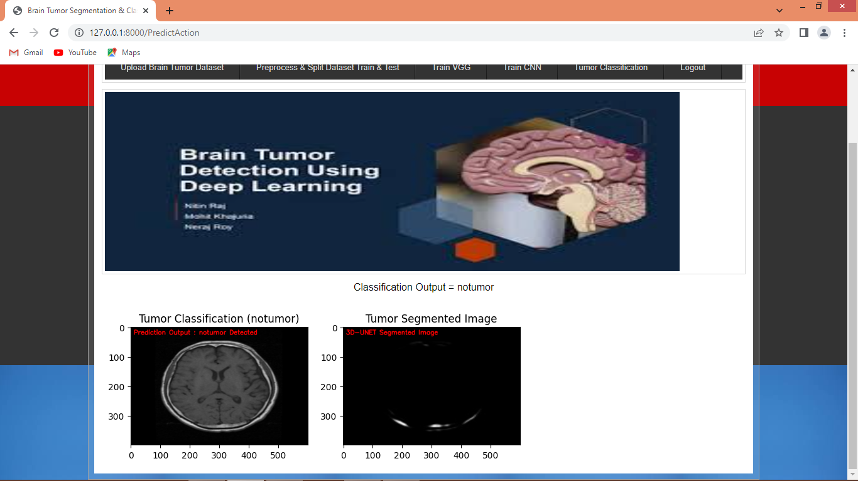
Above screen no tumour detected

Chapter 8
Appendices

Appendix A: Sample Code Snippets
• Example function for preprocessing tabular data

from flask import Flask, render_template, request, redirect, url_for, session import numpy as np import os import pickle

app = Flask(__name__) app.secret_key = 'your_secret_key_here'

users = {}

def load_pickle_model(path):
try:
return pickle.load(open(path, 'rb')) except Exception as e:
print(f"Error loading model from {path}:\n{e}") return None

heart_model =
load_pickle_model(r'C:\Users\Acer\OneDrive\Desktop\My
Projects\Prognosis - Smart-Disease-Predictionmain\notebooks\models\heart.pkl')
diabetes_model = load_pickle_model(r'C:\Users\Acer\OneDrive\Desktop\My
Projects\Prognosis - Smart-Disease-Predictionmain\notebooks\models\diabetes.pkl')
cancer_model =
load_pickle_model(r'C:\Users\Acer\OneDrive\Desktop\My
Projects\Prognosis - Smart-Disease-Predictionmain\notebooks\breast_cancer.pkl')
kidney_model =
load_pickle_model(r'C:\Users\Acer\OneDrive\Desktop\My
Projects\Prognosis - Smart-Disease-Prediction-
main\notebooks\models\kidney.pkl')
liver_model = load_pickle_model(r'C:\Users\Acer\OneDrive\Desktop\My
Projects\Prognosis - Smart-Disease-Predictionmain\notebooks\models\liver.pkl')

@app.route('/') def index(): return redirect(url_for('login'))

@app.route('/register', methods=['GET', 'POST']) def register(): if request.method == 'POST': uname = request.form['username'] email = request.form['email'] password = request.form['password'] users[uname] = {'email': email, 'password': password} return redirect(url_for('login')) return render_template('register.html')

@app.route('/login', methods=['GET', 'POST']) def login(): error = ''
if request.method == 'POST':
uname = request.form['username'] password = request.form['password'] user = users.get(uname) if user and user['password'] == password: session['user'] = uname return redirect(url_for('dashboard'))
else:
error = 'Invalid Credentials!' return render_template('login.html', error=error)

@app.route('/dashboard') def dashboard(): if 'user' not in session:
return redirect(url_for('login')) return render_template('dashboard.html', user=session['user'])

@app.route('/heart', methods=['GET', 'POST']) def heart(): result = advice = None if request.method == 'POST' and heart_model:
features = [float(request.form[key]) for key in request.form] data = np.array([features]) prediction = heart_model.predict(data)[0] if prediction == 1:
result = "Heart Disease Detected"
advice = "Consult a cardiologist and maintain a healthy diet and regular exercise."
else:
result = "No Heart Disease" advice = "Maintain regular checkups and a heart-healthy lifestyle." return render_template('heart.html', result=result, advice=advice)

@app.route('/diabetes', methods=['GET', 'POST']) def diabetes(): result = advice = None if request.method == 'POST' and diabetes_model:
features = [float(request.form[key]) for key in request.form] data = np.array([features]) prediction = diabetes_model.predict(data)[0] if prediction == 1: result = "Diabetic"
advice = "Maintain a healthy diet, monitor blood sugar regularly, and consult a doctor."
else:
result = "Not Diabetic" advice = "Maintain a healthy lifestyle to prevent future risk." return render_template('diabetes.html', result=result, advice=advice)

@app.route('/breast_cancer', methods=['GET', 'POST']) def breast_cancer():
result = advice = None if request.method == 'POST' and cancer_model:
features = [float(request.form[key]) for key in request.form] data = np.array([features]) prediction = cancer_model.predict(data)[0] if prediction == 1:
result = "Malignant (Cancerous)"
advice = "Seek immediate medical attention for further
examination and treatment."
else:
result = "Benign (Non-Cancerous)"
advice = "Continue routine health checkups and breast selfexaminations."
return render_template('breast_cancer.html', result=result, advice=advice)

@app.route('/kidney', methods=['GET', 'POST']) def kidney(): result = advice = None if request.method == 'POST' and kidney_model:
features = [] for key in request.form: val = request.form[key]
try:
features.append(float(val) if val not in ['yes', 'no'] else (1.0 if val
== 'yes' else 0.0)) except:
features.append(0.0) data = np.array([features]) prediction = kidney_model.predict(data)[0] if prediction == 1:
result = "Chronic Kidney Disease"
advice = "Consult a nephrologist and control your blood pressure and sugar levels."
else:
result = "No Kidney Disease"
advice = "Stay hydrated and continue maintaining kidney health." return render_template('kidney.html', result=result, advice=advice)

@app.route('/liver', methods=['GET', 'POST']) def liver():
result = advice = None if request.method == 'POST' and liver_model:
features = [] for key in request.form: val = request.form[key]
try:
features.append(float(val) if val not in ['Male', 'Female'] else (1.0 if val == 'Male' else 0.0)) except:
features.append(0.0) data = np.array([features]) prediction = liver_model.predict(data)[0] if prediction == 1:
result = "Liver Disease Detected"
advice = "Avoid alcohol, follow a liver-friendly diet, and consult a hepatologist."
else:
result = "No Liver Disease" advice = "Maintain a balanced diet and regular health screening." return render_template('liver.html', result=result, advice=advice)

@app.route('/logout')
def logout(): session.pop('user', None) return redirect(url_for('login'))

if __name__ == '__main__': app.run(debug=True)

Appendix B: Dataset Snapshots
- First 5–10 rows of each dataset
- Target variable description

Appendix C: Screenshots
- Registration Page
- Login Page
- Prediction Dashboard
- Sample output for each disease
Appendix D: Additional Notes
- Libraries used: Pandas, NumPy, Matplotlib, Seaborn, OpenCV, PIL, etc.
- Execution environment: Jupyter Notebook, Flask server
- Notes on model export/import using .pkl

Libraries Used
The following Python libraries were utilized in this project for various purposes including data handling, visualization, image processing, and model deployment:
- Pandas: For data manipulation and analysis using dataframes.
- NumPy: For efficient numerical computations and handling arrays.
- Matplotlib: For creating static, animated, and interactive plots and graphs.
- Seaborn: For advanced statistical data visualization built on top of Matplotlib.
- OpenCV: For real-time image processing, loading and transforming image data.
- PIL (Python Imaging Library): For opening, manipulating, and saving many different image file formats.

Execution Environment
- Jupyter Notebook: Used for exploratory data analysis (EDA), model building, training, testing, and evaluation. It offers a user-friendly interface for running Python code in blocks, making it ideal for prototyping and iterative development.
- Flask Server: Used to develop a web-based application interface to interact with the machine learning model. The trained model is integrated with Flask to enable real-time predictions via user input on a web page.

Notes on Model Export/Import Using .pkl
Exporting the Model:
After training and validating the machine learning model in Jupyter Notebook, it is serialized and saved using Python’s pickle module for later use.
import pickle

# Save model to file with open('model.pkl', 'wb') as file: pickle.dump(model, file)

Importing the Model:

In the Flask application (typically in app.py), the model is deserialized and loaded to be used for predictions.
import pickle

# Load model from file with open('model.pkl', 'rb') as file: model = pickle.load(file)

Purpose :
This approach allows decoupling the model training process from the deployment phase. The model does not need to be retrained every time the application is restarted, thus improving efficiency and usability.

Chapter 9

Conclusion:

The development of an automated system for Brain Tumor Segmentation and Classification using 3D U-Net deep neural networks marks a significant advancement in medical image analysis and neuro-oncology. Brain tumors are complex and life-threatening conditions that require timely and precise diagnosis for effective treatment planning. Traditional methods, which rely on manual inspection and classical image processing techniques, are often time-consuming, prone to errors, and limited in their ability to capture complex tumor structures. The proposed system addresses these limitations by leveraging the power of deep learning, specifically the 3D U-Net architecture, which enables volumetric analysis of MRI scans while preserving spatial and contextual information across multiple slices. Through the implementation of advanced preprocessing techniques such as skull stripping, intensity normalization, resizing, and data augmentation, the system ensures high-quality input data for the 3D U-Net model. The encoder–decoder architecture with skip connections allows precise segmentation of tumor sub-regions, including enhancing tumor, tumor core, and edema, while the classification module accurately predicts tumor type or grade. By integrating segmentation and classification into a unified framework, the system reduces error propagation between stages and delivers comprehensive outputs that can be used directly by clinicians.
Extensive evaluation using benchmark datasets such as BraTS demonstrates that the proposed system achieves superior performance compared to conventional methods, with high Dice Similarity Coefficient scores for segmentation and high accuracy, precision, and F1-scores for classification. The system is robust against variations in MRI modalities, tumor heterogeneity, and imaging noise, making it reliable for real-world clinical scenarios. Additionally, the intuitive GUI allows radiologists to interact with the system efficiently, visualize segmentation masks, and interpret classification results without extensive technical expertise.
Overall, the proposed 3D U-Net-based framework provides a fully automated, accurate, and scalable solution for brain tumor analysis. It significantly reduces manual workload, enhances diagnostic precision, and supports clinical decision-making in neuro-oncology. The system’s modular design allows for future enhancements, such as incorporating attention mechanisms, multi-modal fusion, or hybrid models, which could further improve performance. In conclusion, this system not only contributes to the advancement of AI-driven medical imaging but also holds substantial potential for improving patient outcomes through faster, more accurate, and reliable brain tumor diagnosis and treatment planning.

Chapter 10

Future Work

The proposed system for Brain Tumor Segmentation and Classification using 3D U-Net provides a robust framework for automated tumor analysis; however, there remain several avenues for enhancement and future research. One potential direction is the integration of multi-modal and multi-sequence MRI data more effectively. While the current system uses multiple MRI sequences (T1, T1c, T2, FLAIR), advanced fusion techniques could be implemented to combine complementary information from different modalities, which may improve segmentation accuracy and classification performance, particularly in heterogeneous tumors. Additionally, incorporating functional imaging data, such as Diffusion Tensor Imaging (DTI) or perfusion-weighted MRI, could provide deeper insights into tumor characteristics and their aggressiveness. Another promising area is the application of attention mechanisms and transformer-based architectures in the 3D U-Net model. These techniques can enable the network to focus on critical regions of the brain, improving the delineation of tumor boundaries and reducing false positives. Such approaches may also enhance the interpretability of the model by highlighting which regions contributed most to the classification decision, a feature highly valuable in clinical settings. Semi-supervised and self-supervised learning approaches can also be explored to address the challenge of limited annotated datasets. Annotating volumetric MRI scans is labor-intensive and time-consuming; thus, leveraging unlabeled data through advanced learning techniques could significantly expand the training dataset, improve generalization, and real-time deployment and optimization of the system for hospital environments. Implementing a lightweight and scalable model that can run efficiently on standard hospital workstations or cloud-based platforms would make the system accessible to a broader range of healthcare facilities. Additionally, integrating the system with existing hospital PACS (Picture Archiving and Communication Systems) can streamline workflow and allow radiologists to access automated segmentation and classification results directly within their routine diagnostic process.

Chapter 11

References

- Ronneberger, O., Fischer, P., & Brox, T. (2015). U-Net: Convolutional Networks for Biomedical Image Segmentation. Medical Image Computing and Computer-Assisted Intervention (MICCAI), 234–241.
- Cicek, O., Abdulkadir, A. Lienkamp, S. S., Brox, T., & Ronneberger, O. (2016). 3D U-Net: Learning Dense Volumetric Segmentation from Sparse Annotation. Medical Image Computing and Computer-Assisted Intervention (MICCAI), 424–432.
- Havaei, M., Davy, A., Warde-Farley, D., Biard, A., Courville, A., Bengio, Y., … & Larochelle, H. (2017). Brain Tumor Segmentation with Deep Neural Networks. Medical Image Analysis, 35, 18–31.
- Myronenko, A. (2019). 3D MRI Brain Tumor Segmentation Using Autoencoder Regularization. Brainlesion: Glioma, Multiple Sclerosis, Stroke and Traumatic Brain Injuries, 311–320.

